Chapter 10, Problem 53.

Use the concept of source transformation to find V_{o} in the circuit of Fig. 10.97.

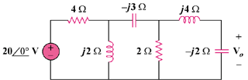

Figure 10.97
For Prob. 10.53.

